TITLE
(do not include author names in document, as the lesson should be blinded for review)

Overview of Lesson
Briefly describe the essence of the lesson plan, including the central investigative question, core statistical concepts, modes of student engagement, and use of tools.

Type of Data
- Choose one: One categorical variable / one quantitative variable / two categorical variables / two quantitative variables / one categorical variable and one quantitative variable / more than two variables
- Choose one: Data generated or collected as a class / static dataset provided by lesson plan authors / publicly available dataset

Learning Objectives
- Format objectives as a bulleted list.
- If relevant, include indices for Common Core State Standards (e.g., 7.SP.3)

Audience
- Indicate the intended audience of students.
- If desired, mention whether this lesson is appropriate for students at different levels.
- Prerequisites: Prior to this lesson, students should have experience with…

Time Required
Estimate minutes or suggest number of class periods (with minutes).

Technology and Other Materials
- Technology: List any technology necessary to analyze data or develop statistical concepts.
- “Low-tech” materials required
- More materials

Lesson Plan

Briefly introduce the lesson plan. This should include a description of the context and the dataset being used. It may also include the teacher’s motivation for developing this lesson. If the idea for the lesson came from an existing resource, reference it in the introduction.

In the sections below, outline the lesson plan. Many authors use an established structure to organize the lesson, such as the GAISE four-step statistical problem-solving process: formulate a question, collect data, analyze data, and interpret results. Alternatively, the sections below illustrate a three-stage lesson: setting the stage, participatory learning in small groups, and wrapping up the lesson as a whole class. This is not prescriptive. Choose the structure that works best for you and your lesson. Whatever structure you choose, be explicit about which parts are teacher-led and which parts involve student participation.

First Stage of the Lesson

Put details here. This should include a clear description of what the teacher is doing and what the students are doing at this stage.

For example, maybe you show a short video to launch the lesson and help students understand why the topic of the lesson is relevant in the real world. Include a link: http://www.interestingvideoforcontext.com/

Maybe you use questions to find out what students already know about the topic.
- Question 1
- Question 2
- Question 3

Second Stage of the Lesson

Put details here. This should include a clear description of what the teacher is doing and what the students are doing at this stage.

For example, maybe students will have the opportunity to explore data in small groups. What information do they need before they get started? Are there skills you need to demonstrate?

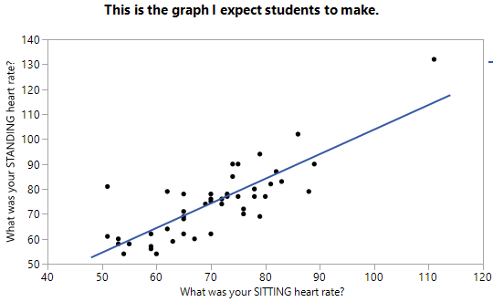
What instructions do you give to students as they start the activity? Make sure your expectations for students are explicit. For example,

- Working with a partner, create an appropriate graph to address the statistical question.
- Answer questions #1-5 on your handout.
- Do x, y, and z to prepare for the class discussion.

Include graphs, screenshots, or other images as necessary to help readers understand what the students will be doing during this stage of the lesson.

What does the teacher do while students are working? Are there common issues that tend to come up? How do you address them? What questions do you ask to monitor student thinking?

Third Stage of the Lesson

Put details here. This should include a clear description of what the teacher is doing and what the students are doing at this stage.

For example, maybe you use a large group discussion to summarize what students learned during the activity. Specify the questions you use to prompt discussion. It may also be helpful to mention common responses.

- Discussion question 1
  - Example of a response that demonstrates incomplete understanding.
  - Example of a correct response
- Discussion question 2
- Discussion question 3

Attached Materials

List any additional materials that are attached. For example:
- Student handouts with sample solutions
- Slides that could be used to give instructions or guide class discussions
- Directions for using a particular technology tool

Reflections and Additional Recommendations (optional)

The contents of this optional section will vary from lesson to lesson. For example, it may include
- Notes about possible extensions of the lesson
- Ideas for differentiation
- Teacher reflections on the lesson (student reactions, changes the teacher is considering)
- Recommendations for where to learn more about relevant teaching approaches or statistical content.

References

List each source using APA citation standards. If data, software, or images were used, these should also be referenced.

