|  |  |
| --- | --- |
| **How Long is 30 Seconds?**  Debra L. Hydorn  University of Mary Washington  [dhydorn@umw.edu](mailto:dhydorn@umw.edu)  **Published: Febuary 2012** | **C:\Users\hstohl\Desktop\JournalEditorialWork\STEW\Website\STEW_logo.gif** |

**Overview of Lesson**

In this activity students conduct an investigation to assess how well individuals can predict the passage of time. Under the guidance of the teacher students design an investigation to discover how successful the class is at predicting when 30 seconds has passed. Issues to consider include possible biases in data collection. Students construct box plots for the class results and calculate measures of center and spread. These analyses are repeated for the data separated for boys and girls. Comparisons are made between groups and also to the target of 30 seconds.

**GAISE Components**

This investigation follows the four components of statistical problem solving put forth in the *Guidelines for Assessment and Instruction in Statistics Education (GAISE) Report*. The four components are: formulate a question, design and implement a plan to collect data, analyze the data by measures and graphs, and interpret the results in the context of the original question. This is a GAISE Level B activity.

**Common Core State Standards for Mathematical Practice**

4. Model with mathematics.

5. Use appropriate tools strategically.

**Common Core State Standards Grade Level Content (Grades 6 through 7)**

6. SP. Develop understanding of statistical variability.

6. SP. Summarize and describe distributions.

7. SP. Draw informal comparative inferences between two populations.

**NCTM Principles and Standards for School Mathematics**

**Data Analysis and Probability Standards for Grades 6-8**

**Formulate questions that can be addressed with data and collect, organize, and display relevant data to answer them:**

* formulate questions, design studies, and collect data about a characteristic shared by two populations or different characteristics within one population;
* select, create, and use appropriate graphical representations of data, including histograms, box plots, and scatterplots.

**Select and use appropriate statistical methods to analyze data:**

* find, use and interpret measures of center and spread, including mean and inter-quartile range;
* discuss and understand correspondence between data sets and their graphical representations, especially histograms, stem-and-leaf plots, box plots and scatterplots.

**Prerequisites**

Students should have prior experience collecting data and calculating measures of center and spread and constructing box plots of quantitative data.

**Learning Targets**

Students will interpret box plots that compare two groups. They will also interpret and compare measures of center and spread.

**Time Required**

One class period.

**Materials Required**

Stopwatches (wristwatches or a wall clock with a second hand may also be used).

**Instructional Lesson Plan**

**The GAISE Statistical Problem-Solving Procedure**

**I. Formulate a Question**

Begin the lesson by asking the students if they think they are good judges of time. Encourage the students to consider situations where being able to accurately determine how much time has passed could be important (e.g., waiting for an emergency crew to arrive, completing an assigned task within a specified amount of time). Demonstrate the use of a stopwatch and describe how it works. For example, choose a passage from a previous lesson and time how long it takes to read it out loud. Explain that the class will conduct an investigation to determine how accurate the class is at predicting when 30 seconds has passed.

Possible questions to ask:

1. How can we measure how accurate someone is at telling how much time has passed?

2. Are girls better at predicting the passage of time than boys?

3. Can practicing improve accuracy in predicting the passage of time?

**II. Design and Implement a Plan to Collect the Data**

Guide the students in creating an investigation to discover how accurate the class is at predicting when 30 seconds has passed. Discuss the implications of possible biases in data collection. Among other issues, students should consider how to make sure that they cannot see a clock in the classroom while being timed and that those who are not being timed are not practicing by “shadowing” other students who are being timed. That is, students should not be allowed to observe when other students are being timed so that they “learn” how long 30 seconds takes to pass. They should also consider whether or not a single person should operate the stopwatch and if a person can measure his or her own time. Establish all of the procedures before handing out the stopwatches. Remind students that there is more than one way to collect this data and that some ways will be better than others. Also remind them that everyone must follow the same procedure for collecting the data. Divide the class into groups so that each group has one stop watch. Give students the opportunity to practice using the stopwatches, including recording results and resetting the stopwatch. Have them perform the experiment and record the data.

Another way to collect the data would be for the teacher to work with each student individually, perhaps in the back of the classroom. Students could be given a worksheet or other activity to occupy them during the data collection. To collect the data the teacher could say something to the student similar to: “Say ‘Start’ when you want me to start the stop watch and say ‘Stop’ when you think 30 seconds has passed and you want me to stop the stop watch.” The teacher would then tell the student how many seconds had actually passed, which the student would then record on the activity sheet.

After everyone has had their prediction recorded, collect and record the class data. Remind students that this is a census of the class because data is gathered from every student in the class.

**III. Analyze the Data**

There are various ways to analyze the collected data. For example, the class can calculate measures of center and spread. A box plot can be constructed from the class data. The analyses can be repeated separately for the boys and girls in class. Table 1 provides some example class data.

Table 1. Example class data.

|  |  |  |  |
| --- | --- | --- | --- |
| **Gender** | **Time Estimate** | **Gender** | **Time Estimate** |
| Female | 21 | Female | 37 |
| Male | 26 | Male | 19 |
| Male | 35 | Female | 19 |
| Male | 36 | Female | 20 |
| Female | 32 | Male | 15 |
| Male | 18 | Female | 30 |
| Male | 40 | Male | 44 |
| Female | 34 | Male | 15 |
| Female | 14 | Female | 29 |
| Female | 33 | Male | 33 |

A box plot of the example class data is shown in Figure 1.

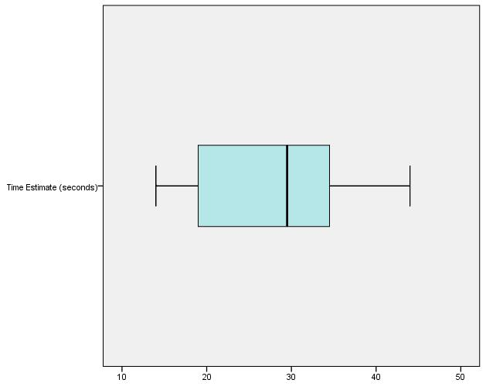

Figure 1. Box plot for example class data.

From the box plot it can be seen that a median guess was slightly lower than 30 seconds. The middle 50% of the guess distribution ranged from about 19 seconds to about 35 seconds (as seen by the inter-quartile range). The shortest guess is at about 15 seconds and the longest guess is about 45 seconds.

Numerical calculations for the example class data show that the mean guessed time was 27.50 seconds. The median guessed time was 29.50 seconds. The teacher can discuss with students that the median represents the 50th percentile of the distribution of guessed times. About half the times are less than 29.50 seconds and about half the times are more than 29.50 seconds. A typical student guessed 27.50 seconds as seen by the mean. The standard deviation of 9.20 seconds indicates a typical difference between the student guesses and the mean.

Class data can be separated by gender and the guess distributions can be compared. Comparative box plots, for example female and male guessing times, are shown in Figure 2.

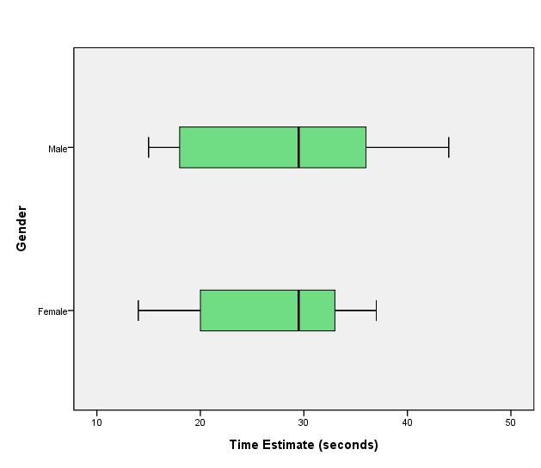

Figure 2. Comparative box plots for example class data.

The box plots show that the median guessed time is roughly the same for males and females. The female interquartile range is smaller than the male interquartile range. This indicates that the male guessing times tended to be more variable.

The numerical calculations show that for the females the mean guessed time was 26.90 seconds while the male mean was 28.10 seconds. A typical female guessed about 1 second shorter than a typical male. The male standard deviation of 10.86 is over 3 seconds more than the female standard deviation 7.75. This indicates that the male guesses were more variable than the female guesses. The median female and male guessed times were equal at 29.50 seconds. The interquartile range for female guesses, 14 seconds, is smaller than the interquartile range for male guesses, 20 seconds. This is another indication of the larger variation in the male guesses.

**IV. Interpret the Results**

In addition to interpretive points made in analyzing the data, the students can be prompted to generate and answer further data analysis questions such as:

* On average, how close were the students in our class at estimating when 30 seconds has passed? How much do the predictions of 30 seconds vary?
* What percentage of the class is within 5 seconds of the correct time (that is, have a prediction of 30 seconds that is between 25 and 35 seconds)?
* Are students more likely to overestimate or underestimate when 30 seconds have passed?
* What generalizations, if any, can we make using the results from this experiment?

**Assessment**

Suppose that Jeremy’s class produced the following results when performing this experiment:

|  |  |  |
| --- | --- | --- |
| Our Class Data: Predictions of When 30 Seconds Has Passed (seconds) | | |
| Karen | 21 | F |
| Joshua | 26 | M |
| Jamal | 35 | M |
| Trevor | 36 | M |
| Alicia | 32 | F |
| John | 18 | M |
| Bob | 40 | M |
| Barb | 34 | F |
| Kathi | 14 | F |
| Joannie | 33 | F |
| Mary | 37 | F |
| Lee | 19 | M |
| Jamie | 19 | F |
| Leilani | 20 | F |
| Reid | 15 | M |

Use the approaches below to determine how accurately the class predicted when 30 seconds has passed.

1. Find the mean, median and range for the predictions of when 30 seconds has passed for the class data. Describe how accurate the predictions were. How many of the predictions are within 5 seconds of 30 seconds? How many predictions are below 30 seconds? How many are above?

2. Produce a box plot of the prediction times. Describe the distribution of prediction times.

3. Find the mean, median and range for the predictions made by boys and for the predictions made by girls. Compare the accuracy of the predictions made by these two groups.

4. Produce separate box plots for the predictions made by the boys and girls. Compare the distributions.

**Answers**

1. The mean is 399/15 = 26.6 seconds. The ordered times are:

14 15 18 19 19 20 21 26 32 33 34 35 36 37 40

The median prediction is 26 seconds and the range is  seconds. Eight students had a prediction that was less than 30 seconds and seven had a prediction that was more than 30 seconds. Five of the predictions are within 5 seconds of 30 seconds (26, 32, 33, 34 and 35).

Interpretations: On average the predictions are about 3 or 4 seconds less than 30 seconds and the difference between the lowest and highest predictions is 26 seconds.

2. The box plot is shown below:



The distribution is roughly symmetric.

3. The results are shown in the table below:

|  |  |  |  |
| --- | --- | --- | --- |
|  | Mean | Median | Range |
| Boys | 27 seconds | 26 seconds | 25 seconds |
| Girls | 26.25 seconds | 26.5 seconds | 23 seconds |

The measures of center and spread for the boys and girls are similar in value. Two of the boys’ predictions are within 5 seconds of 30 seconds (26 and 35) and three of the girls predictions are within 5 seconds of 30 seconds (32, 33, and 34).

4. The box plots are shown below:



The box plots are similar. They are both symmetric with roughly the same five-number summaries. The medians are very close. The range for the girls is slightly lower than the range for the boys.

**Possible Extensions**

1. After the box plots are constructed the teacher can ask the students to construct histograms of the data.

2. This activity can be extended to earlier grades by recording if predictions are 30 seconds or less or above 30 seconds. Students can construct a bar chart or pie chart and find percentages in each category.

3. To explore the possible impacts of practicing students could repeat this experiment after practicing or using a technique such as reciting “one Mississippi, two Mississippi,…” to count out 30 seconds. They could also determine if age has effect on a person’s ability to predict the passage of time by collecting data on younger or older students.

**References**

Adapted from an activity created by Paul J. Fields, Ph.D. for the *American Statistical Association Meeting Within a Meeting Program for Middle School Teachers* (2008).



**How Long is 30 Seconds? Activity Sheet**

**1.** What are some questions we should ask to determine how accurate a person is at predicting the passage of time?

**2.** Record your prediction for when 30 seconds has passed: \_\_\_\_\_\_\_\_\_\_\_ seconds

**3.** Record the results for the class in the following table:

|  |  |  |  |  |  |
| --- | --- | --- | --- | --- | --- |
| Name | Prediction  (seconds) | Boy or Girl? | Name | Prediction (seconds) | Boy or  Girl? |
|  |  |  |  |  |  |
|  |  |  |  |  |  |
|  |  |  |  |  |  |
|  |  |  |  |  |  |
|  |  |  |  |  |  |
|  |  |  |  |  |  |
|  |  |  |  |  |  |
|  |  |  |  |  |  |
|  |  |  |  |  |  |
|  |  |  |  |  |  |

**4.** Sort the predictions from smallest to largest.

**5.** Using the sorted data find the mean, median and range:

**6.** Using the sorted data, find the values needed to construct a box plot of the data:

**7.** Construct the box plot:

**8.** Describe the accuracy of the class’ predictions of when 30 seconds has passed:

**9.** Separate the class data into two groups, one for boys and the other for girls:

**Data for Girls:**

|  |  |
| --- | --- |
| Name | Prediction (seconds) |
|  |  |
|  |  |
|  |  |
|  |  |
|  |  |
|  |  |
|  |  |
|  |  |
|  |  |
|  |  |

**Data for Boys:**

|  |  |
| --- | --- |
| Name | Prediction (seconds) |
|  |  |
|  |  |
|  |  |
|  |  |
|  |  |
|  |  |
|  |  |
|  |  |
|  |  |
|  |  |

**10.** Sort the group data from smallest to largest:

**Girls:**

**Boys:**

**11.** Using the sorted data, find the mean, median and range for the girls’ data and for the boys’ data:

**12.** Using the sorted data, find the values needed to construct box plots for the girls’ and boys’ data:

**13.** Construct box plots for the girls’ and boys’ data:

**14.** Compare the boys’ and girls’ distributions: